# TheWord Bible Editor

## Overview

This is a prototype of an editor for TheWord bible modules. This is an outline of the tool and its basic functionalities.

## Main window

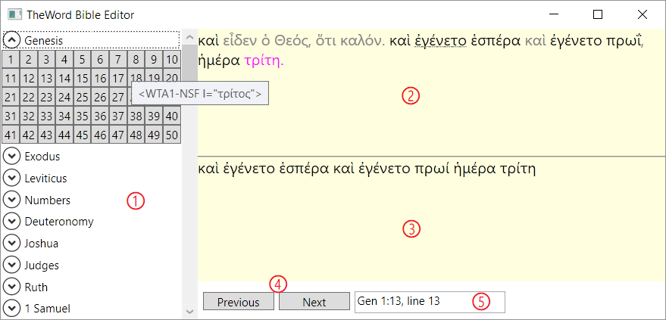

This is the editor main window. It has the following main parts:

1. The navigator, at the left. Use it to navigate to a chapter of a book.
2. The main verse viewer/editor at the top right, where you will view/edit your bible module verse by verse.
3. The secondary verse viewer, always synchronized to the first module, located bellow the main verse viewer. You should load here the module from which you are borrowing the metadata, like strong and morphology tags. I’ve set this to read-only mode, but we can reconsider that.
4. **Previous** and **Next** buttons to navigate the modules verse by verse.
5. The reference/line viewer/textbox. It always displays the current reference and line number. It can be used to jump to a specific verse by typing a line number it directly into the field and pressing <Enter>. This should work like the <F4> search box in TheWord in the future, allowing for references too.

## Loading a bible module

To load a bible module into one of the viewers, right-click it and click **Open…** In the open file dialog choose a non-encrypted TheWord bible module. The application will remember the modules you’ve loaded and restore them when you reopen it.

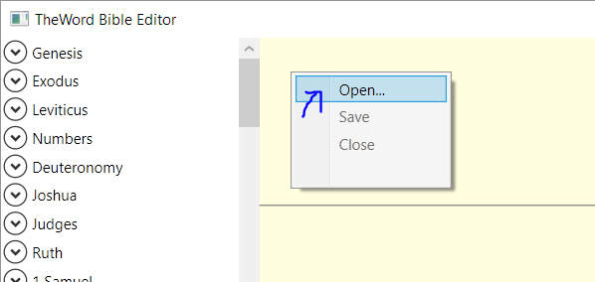

The viewer will show verses with some relevant formatting:

* Words with tags associated will be shown in black font. Hover the mouse pointer over the word to see the raw tags in a tooltip.
* Words with no tags will be shown in gray.
* Words marked for review will be underlined. More on this later.

## Editing

There are some options available to edit a verse. First, you can edit it in the raw form you’d see if you’ve opened the module in a plain text editor. To do that, double-click an empty area of the viewer. Press <Esc> to exit the raw editor and go back. Any editing you do will be retained. In the raw editor textbox you can use Ctrl+Z to undo and Ctrl+Y to redo any editing.

Second, you can edit a word by using its context menu accessible by a mouse right-click. You’ll be presented with the following menu:

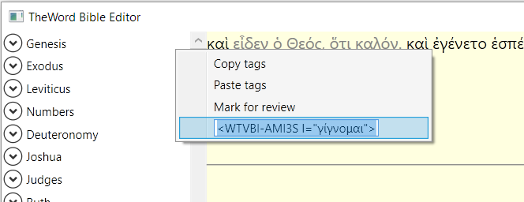

The available options are:

* **Copy tags**: copies the tags associated with the word to the clipboard.
* **Paste tags**: replaces the word tags with the clipboard content. This allow you to copy tags from a word in one verse viewer and paste them to a word in the other.
* **Mark for review**: This is a convenience feature. It appends the tag “<?>” to the word. This tag has absolutely no meaning in TheWord, and the only effect will be that the word will be shown underlined here in this editor when it is present. If the tag is already present, this option will be exhibited as “Mark as reviewed” and will remove the “<?>” tag when clicked.
* **Tags textbox**: here you can edit the tags associated with the word. Press <Enter> to apply any modification or <Esc> to ignore them.

Once you’ve made any changes the **Save** option becomes enabled in the verse context menu. Select it to write the changes to the disk.

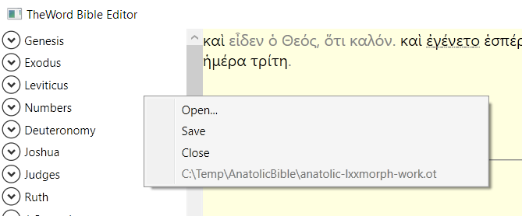

*I haven’t tested but I suspect that if the module is opened in TheWord the editor won’t be able to save it. If that’s the case, I may consider another saving strategy in the future to allow this.*

The context menu also has the **Close** option. It unloads the module and clears the verse view. If there are unsaved changes it will offer you the option to save it before the module is closed. Even though I’ve included this option, it may not be that useful. I think it’s better to leave the modules open when you exit the application, because it will remember and reopen them when you came back.

## Navigator

The navigator is still rudimentary and provides navigation only down to the level of a chapter for now. I’ll work on it later.

Click a book name to view its chapters. Click a chapter to go to its first verse.

The navigator will synchronize the current verse with TheWord application if it is open. This will allow you to have one or more Bibles open on TheWord to use as a reference.